* API call:

Created a Python API script that extracts 3 entities "CHARACTERS", "BOOKS" and "HOUSES”. Script iterates through all the pages in a call using Next link after it creates tables in sql database. If table exists it overrides it in order to keep newest information from a source.

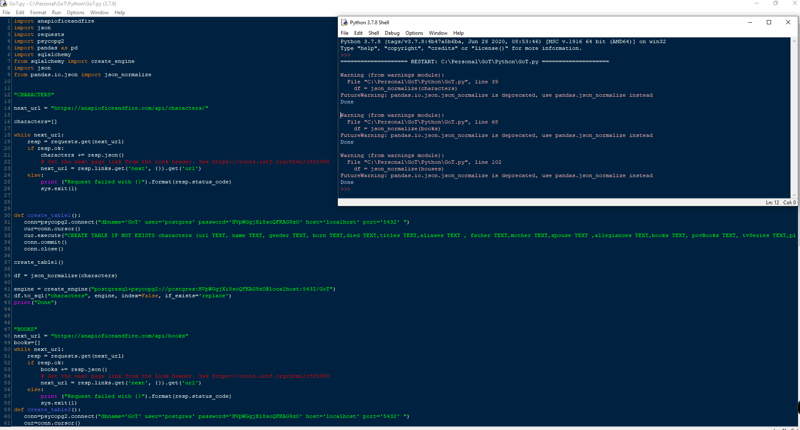

* PostgreSQL

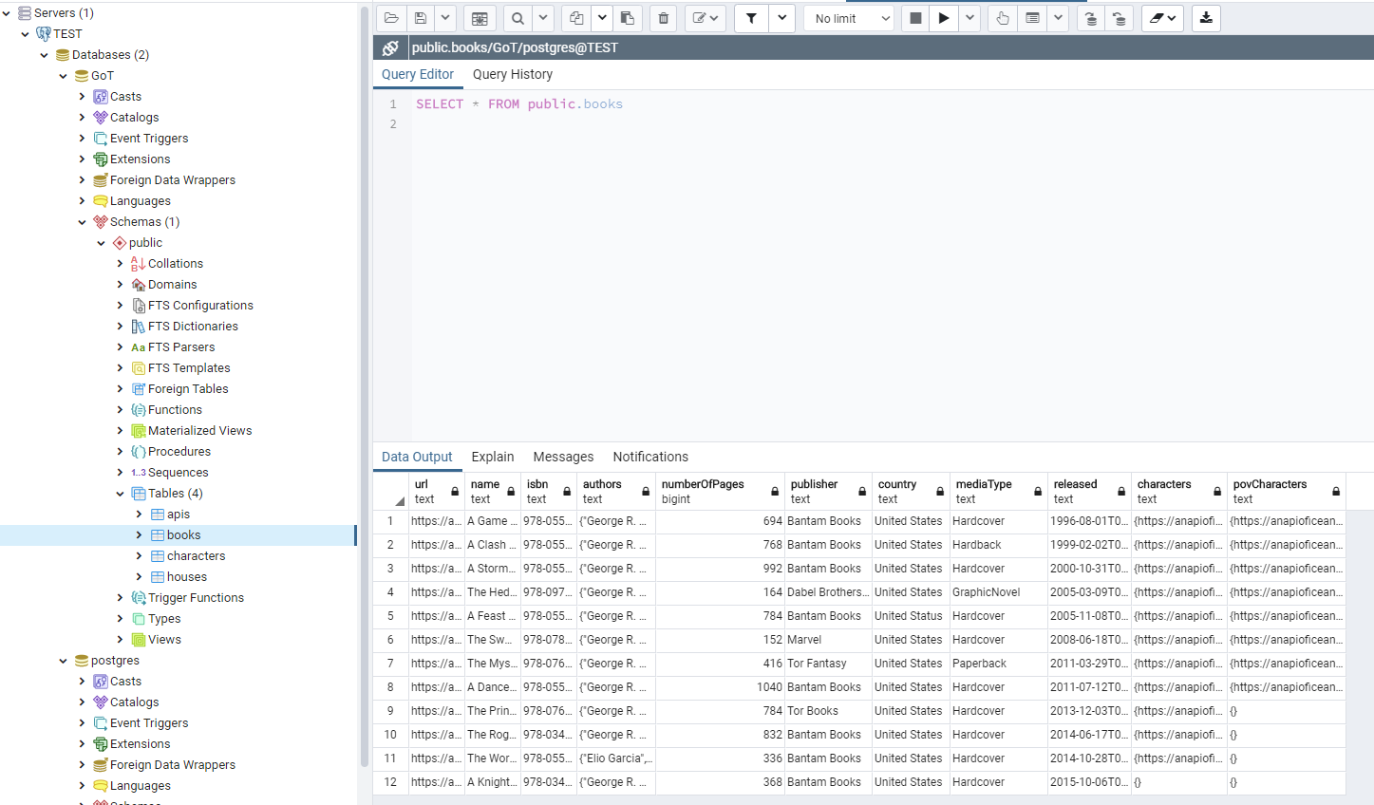

* Power BI

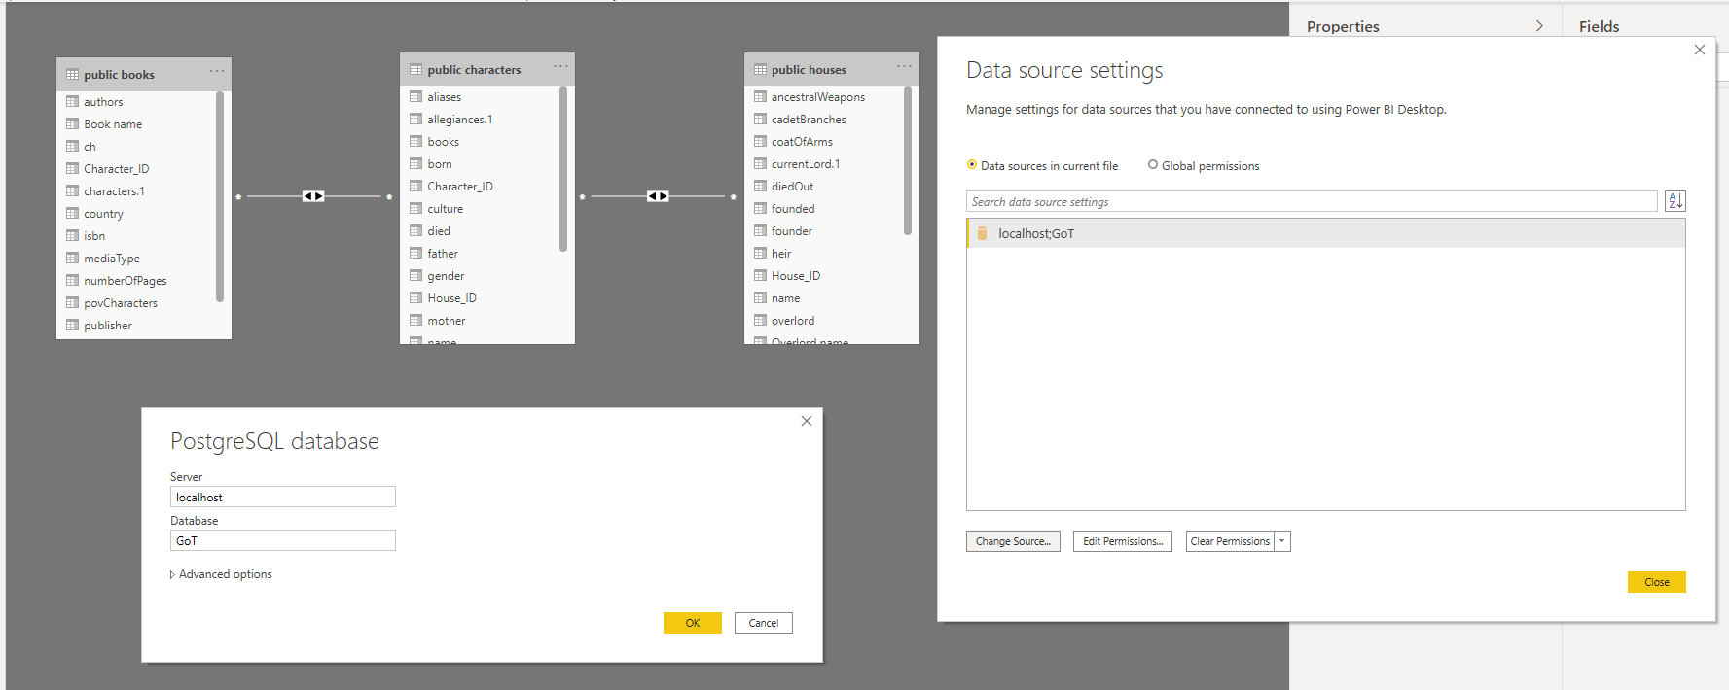

Books query

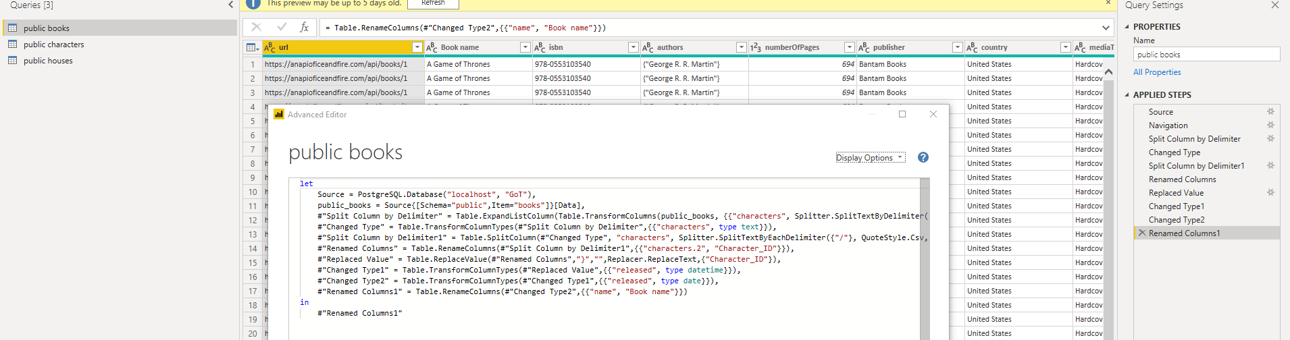

Characters Query

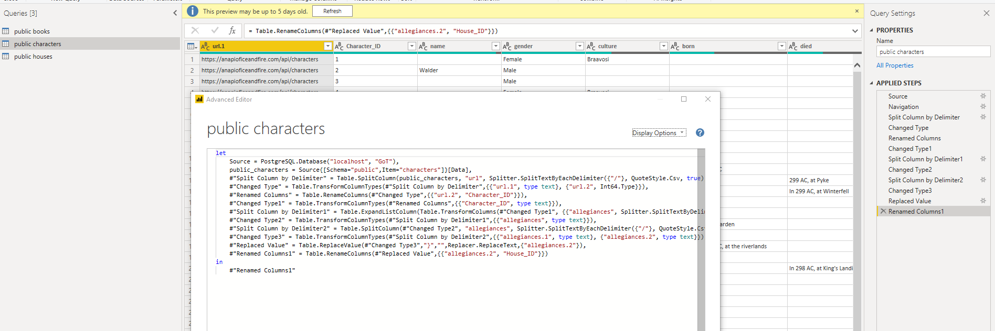

House query

